PolicyEngine POSE Phase I Budget Impact Statement

# E. Travel ($35,757) - Details

Table 1 below (also in the budget justification) summarizes the costs for each event. In subsections below, we document each cost component with screenshots from Google Flights, GSA’s per diem rate tool, conference registration pages, and event space companies. For conferences that have not yet published 2026 registration cost or location, we assume that of the 2025 conference (each is annual).

**Table 1: Cost of each conference and hosted community event.**

| **Conference / Event** | **Start date** | **End date** | **Location** | **Registration** | **Per diem** | **Flights** | **Total per person** | **Total @ 2 people** | **Meeting space** | **Grand total** |
| --- | --- | --- | --- | --- | --- | --- | --- | --- | --- | --- |
| **NAWRS** | 8/3/25 | 8/6/25 | Charlotte NC | $899 | $372 | $299 | $1,570 | $3,140 | $0 | $3,140 |
| **Code for America Summit** | 5/1/26 | 5/3/26 | Chicago IL | $899 | $673 | $163 | $1,735 | $3,470 | $0 | $3,470 |
| **SciPy** | 7/7/26 | 7/13/26 | Tacoma WA | $1,150 | $1,375 | $439 | $2,964 | $5,928 | $0 | $5,928 |
| **NCSL Legislative Summit** | 8/3/25 | 8/7/25 | Boston MA | $1,365 | $1,578 | $224 | $3,167 | $6,334 | $0 | $6,334 |
| **ASSA 2026 Annual Meeting** | 1/3/25 | 1/5/25 | Philadelphia PA | $290 | $1,038 | $186 | $1,514 | $3,028 | $0 | $3,028 |
| **Hosted Community event** | 1/4/26 | 1/6/26 | Austin TX | $0 | $1,038 | $483 | $1,521 | $3,042 | $1,055 | $4,097 |
| **Hosted Community event** | 1/11/26 | 1/13/26 | Denver CO | $0 | $560 | $303 | $863 | $1,726 | $750 | $2,476 |
| **Hosted Community event** | 4/1/26 | 4/3/26 | Los Angeles CA | $0 | $874 | $417 | $1,291 | $2,582 | $1,350 | $3,932 |
| **Hosted Community event** | 2/8/26 | 2/11/26 | San Francisco CA | $0 | $1,099 | $357 | $1,456 | $2,912 | $440 | $3,352 |

## NAWRS

At the National Association for Welfare Research & Statistics conference in Charlotte, we will engage researchers who could use PolicyEngine’s benefit model for benefit access studies and policy research.

<https://www.nawrs.org/events/event-one-yl94e>

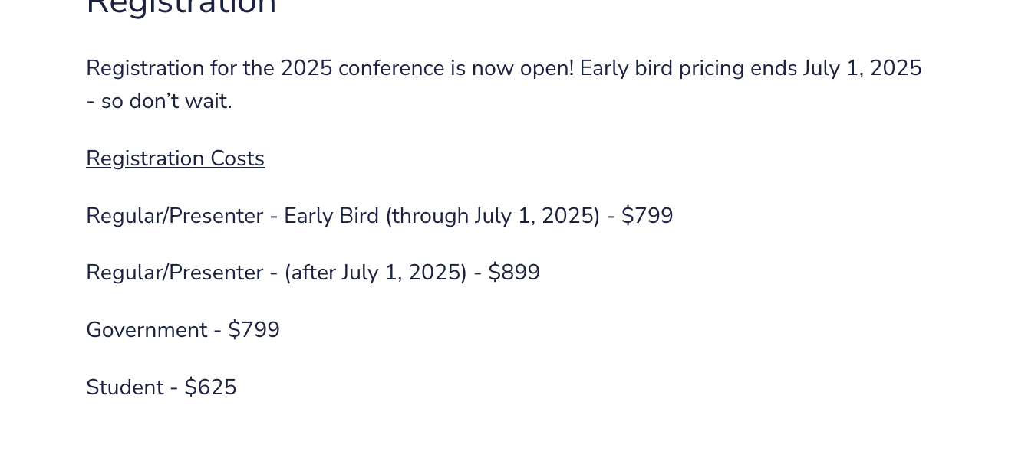

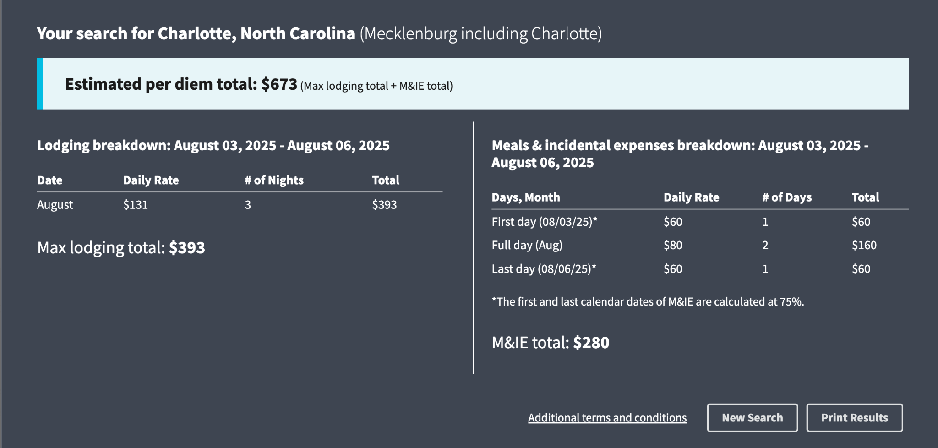

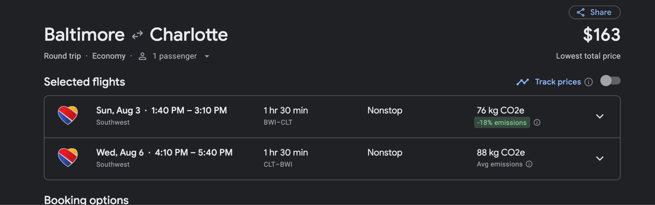

## Code for America Summit

At the Code for America Summit in Chicago, we will engage the civic tech community.

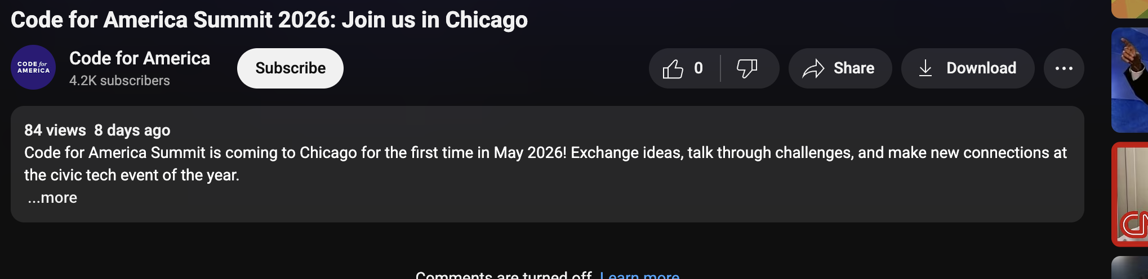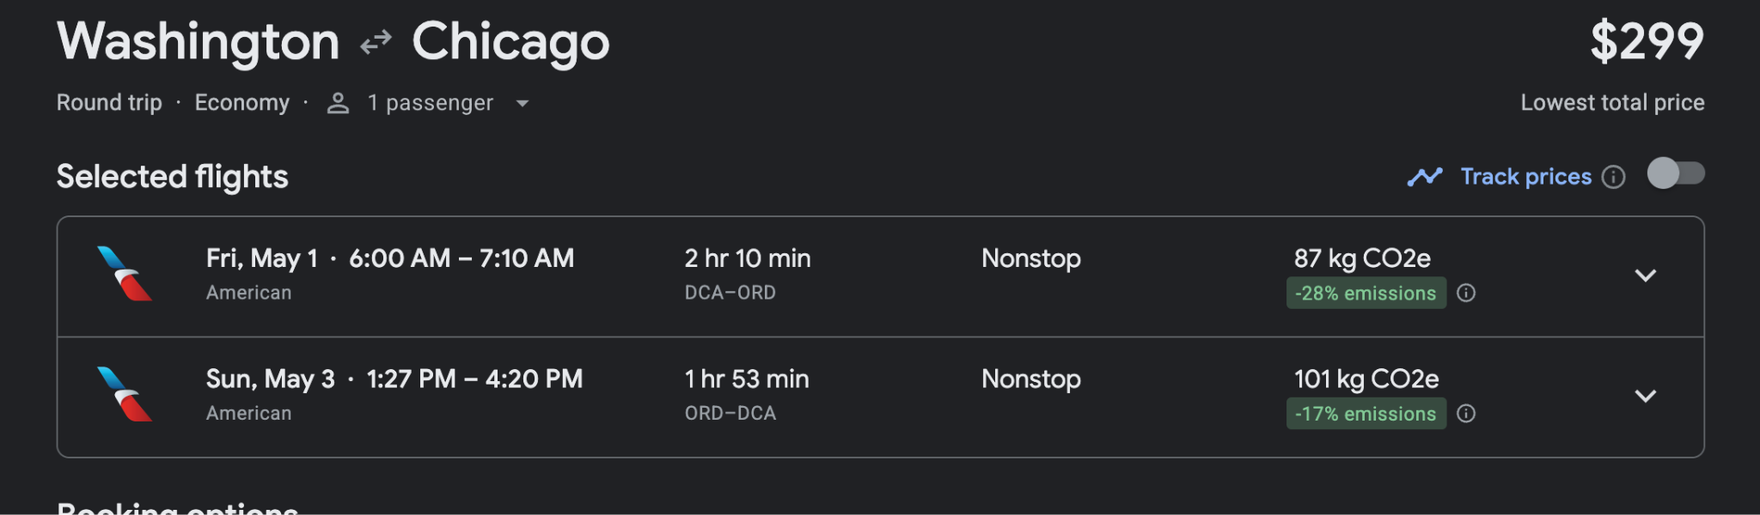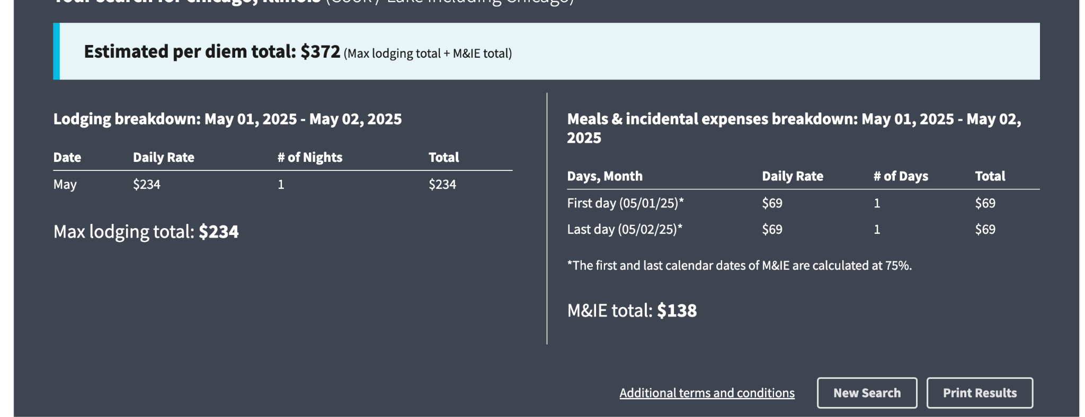

## SciPy

At the SciPy conference, we will engage the open source Python scientific community.

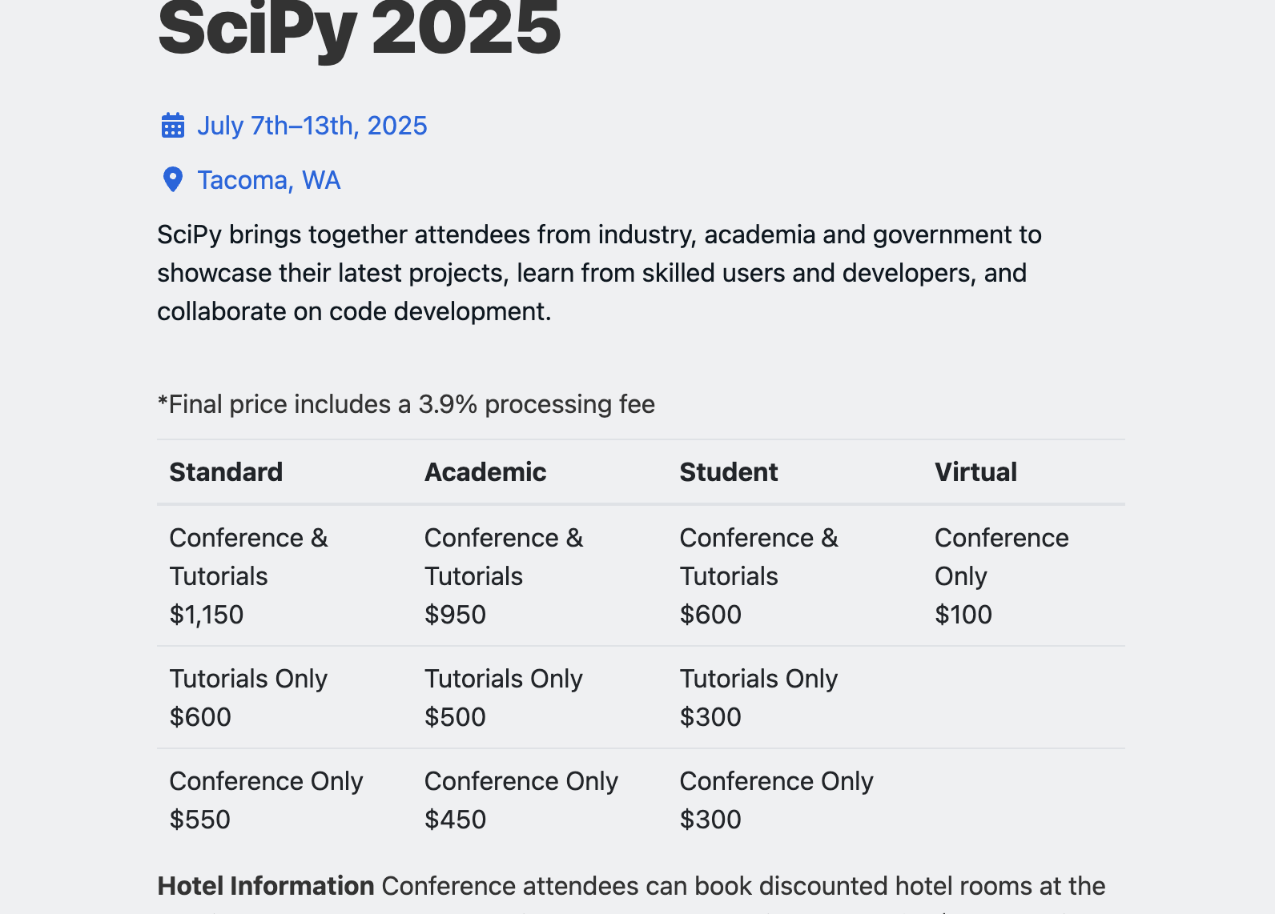

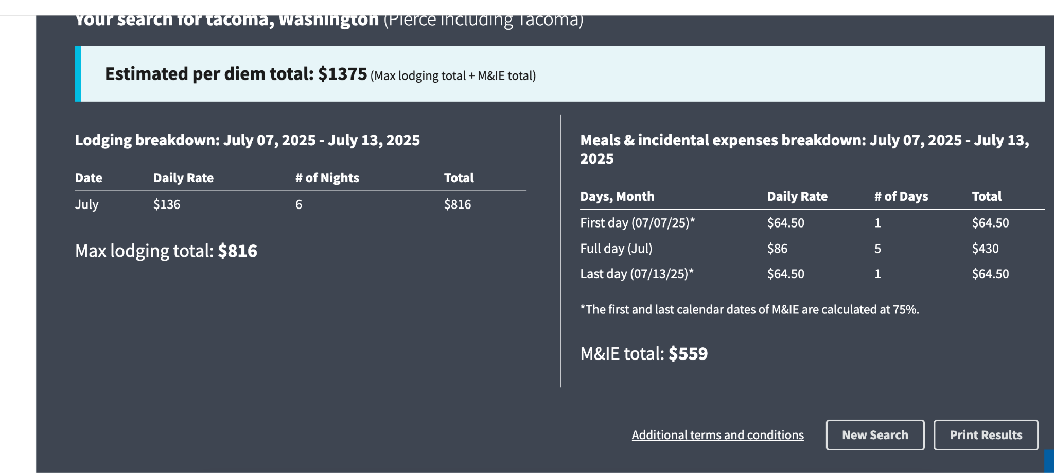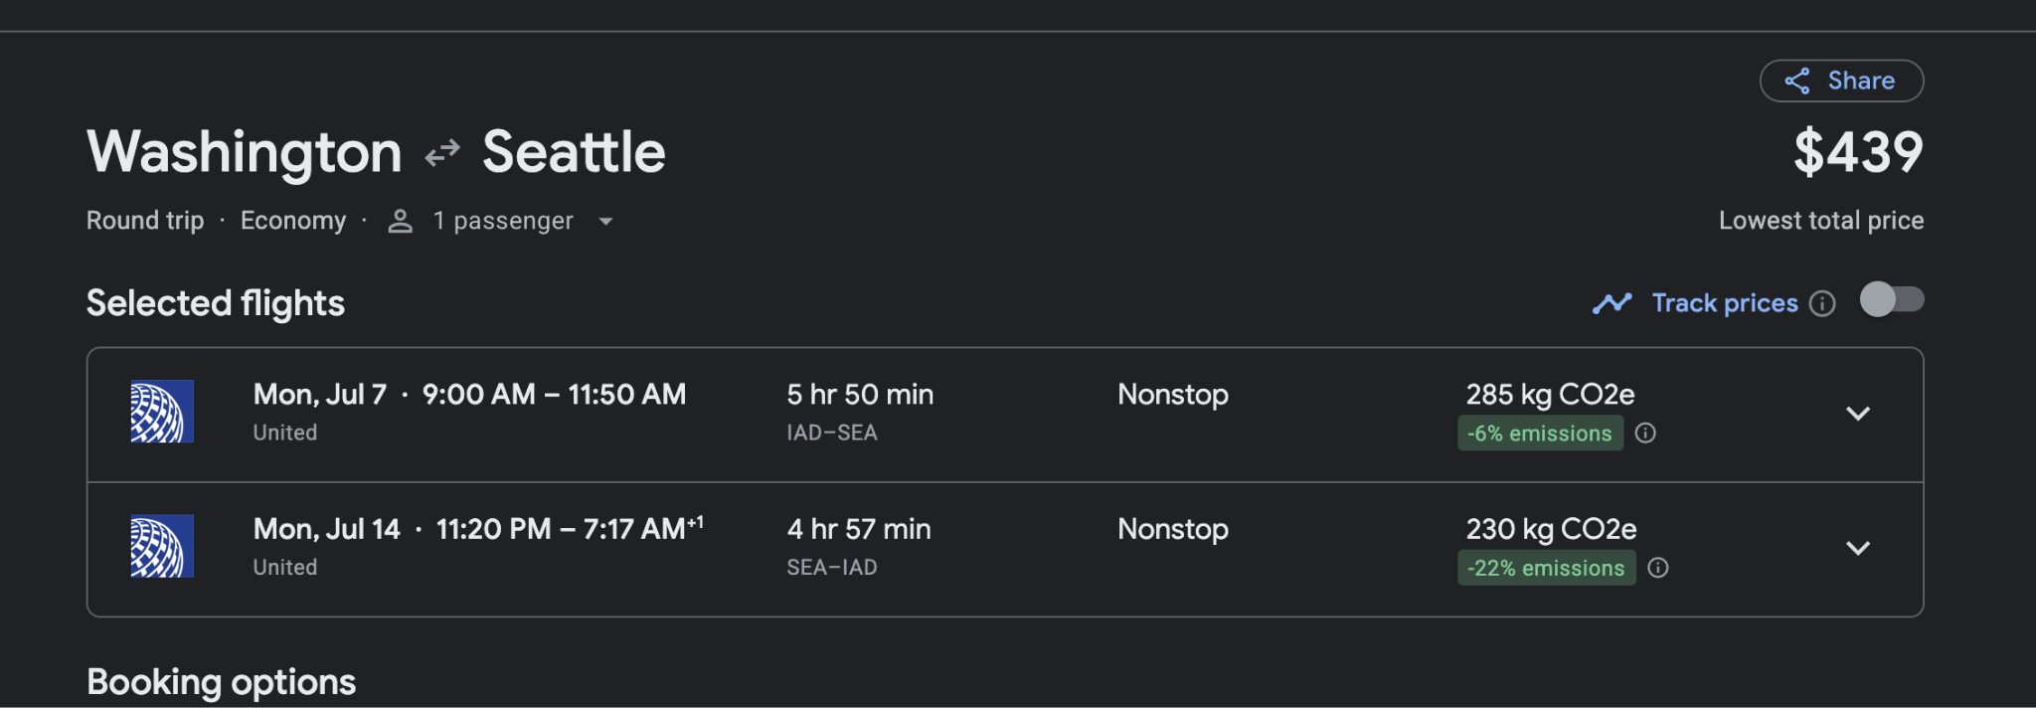

## **NCSL Legislative Summit**

At the National Conference of State Legislatures Legislative Summit in Boston, we will engage policy researchers and practitioners of state-level tax and benefit programs.

## 

## [ASSA 2026 Annual Meeting](https://www.aeaweb.org/conference/)

At the annual Allied Social Science Associations (ASSA) meeting, held each year by the American Economic Association in conjunction with 66 other associations, we will engage the public economics research community.

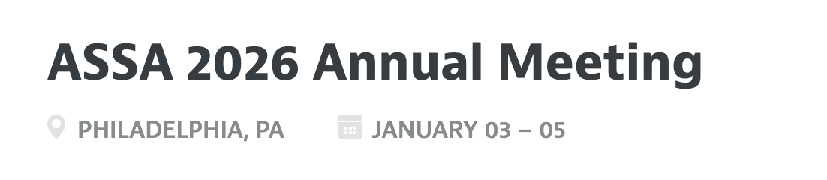

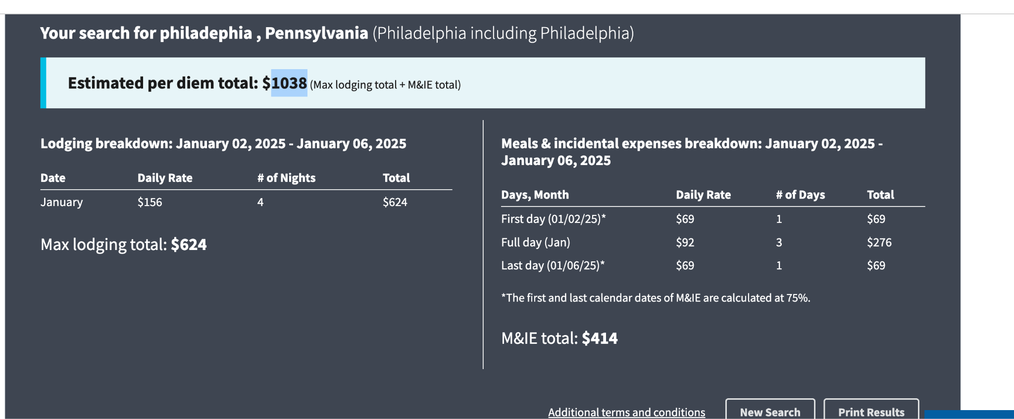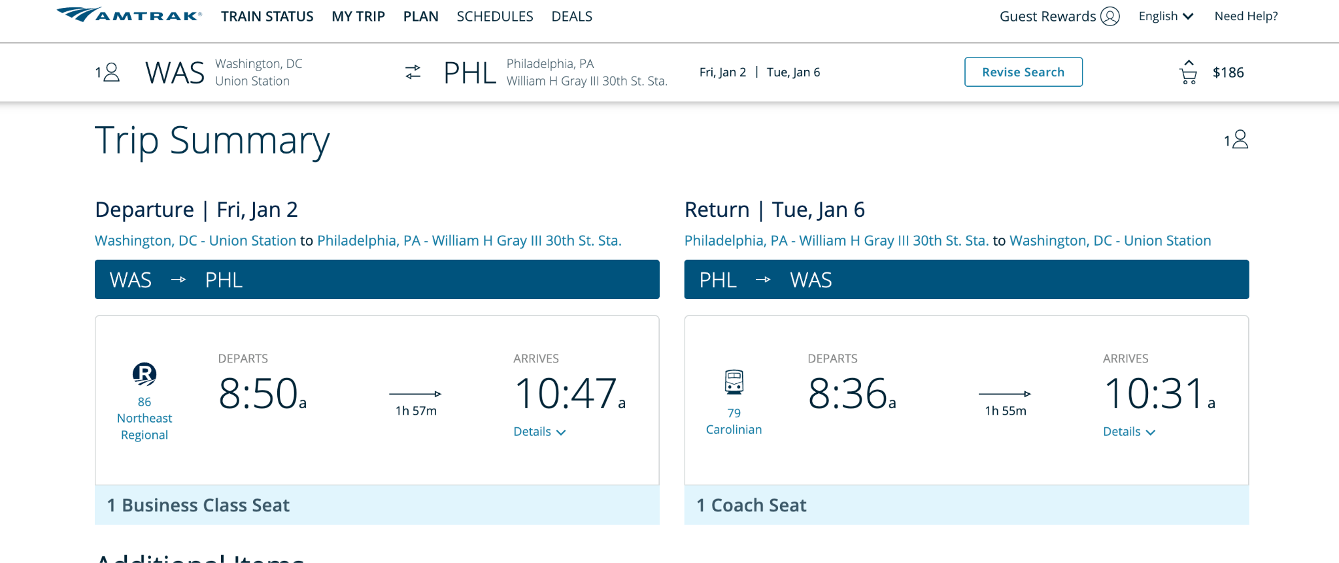

## Stakeholder Engagement Meeting - Austin

In Austin, we will connect with the strong civic tech community and researchers at UT Austin and other institutions.

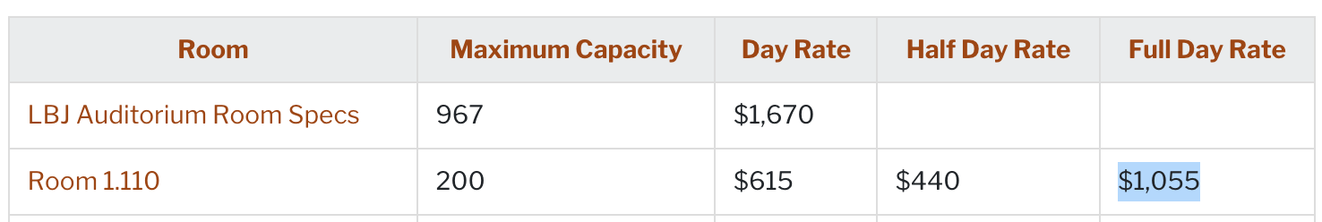

<https://thompsoncenter.utexas.edu/campus#:~:text=Room%201,315%20%20%24220%20%20%24535>

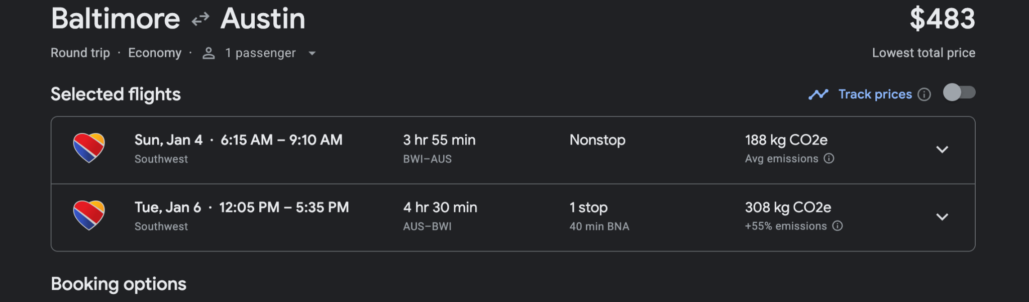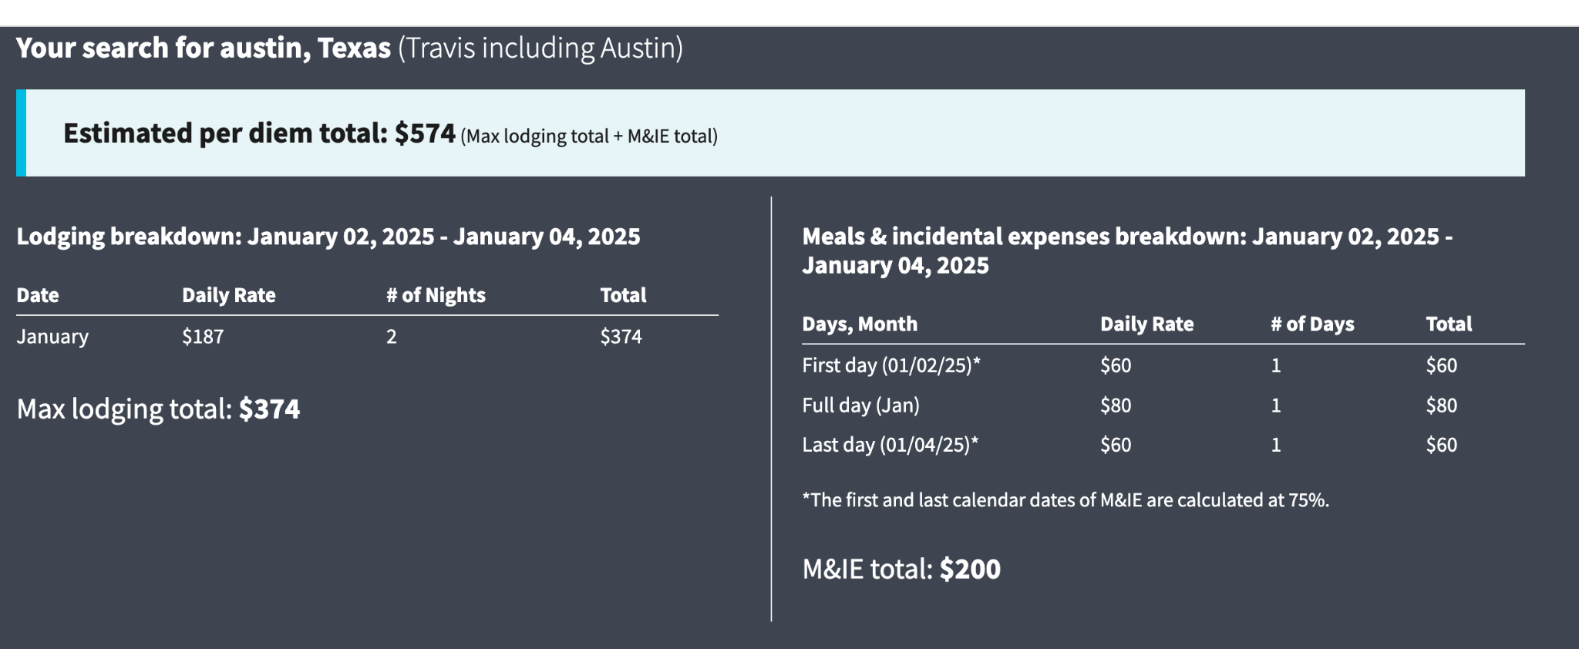

### Stakeholder Engagement Meeting - Denver

In Denver, where we already work with Gary Community Ventures, MyFriendBen, and the Colorado Fiscal Institute, we will engage the local civic tech and Colorado policy research community.

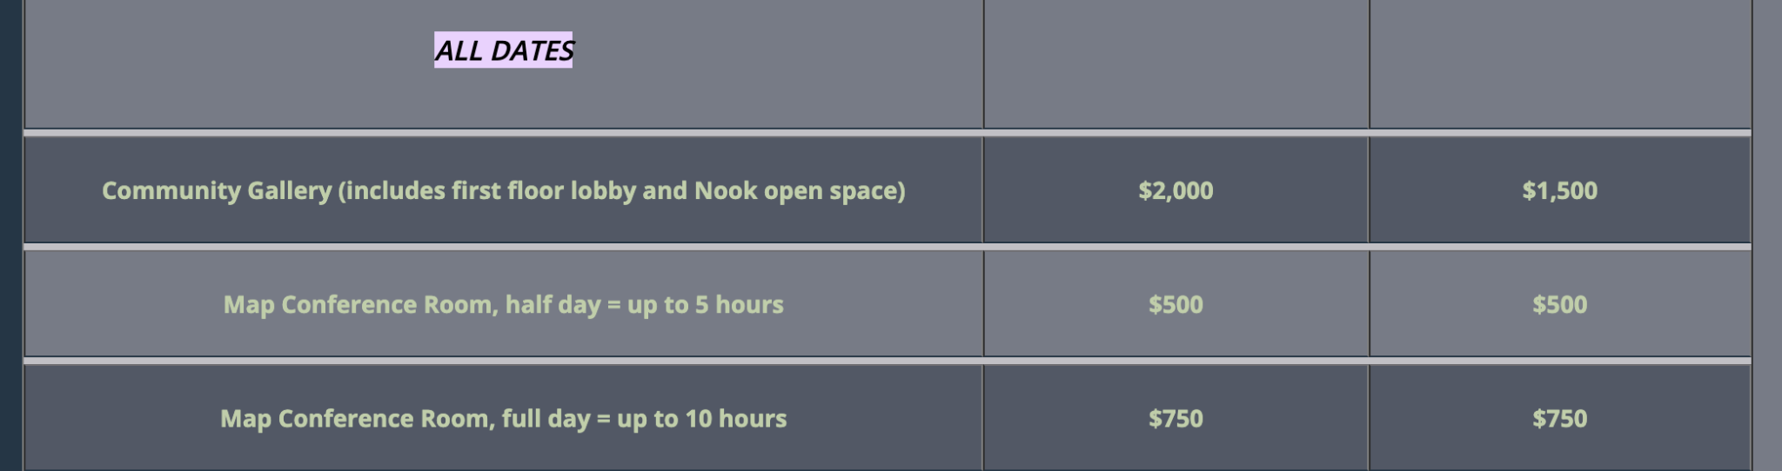

<https://www.mcnicholsbuilding.com/private-events-rentals/capacity-and-rates>

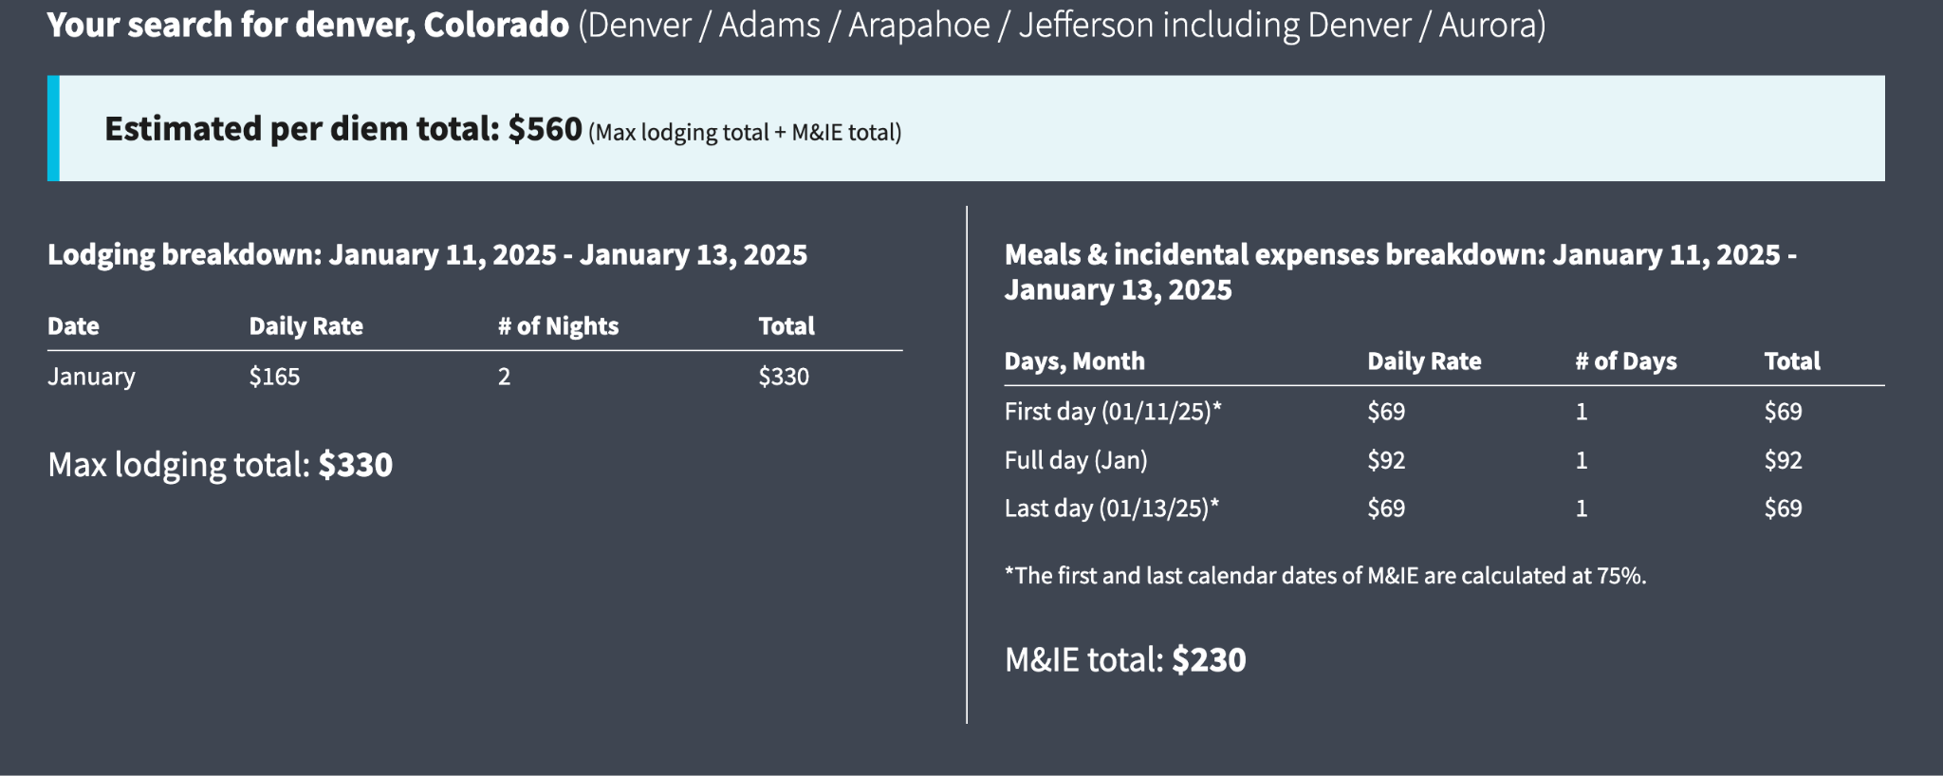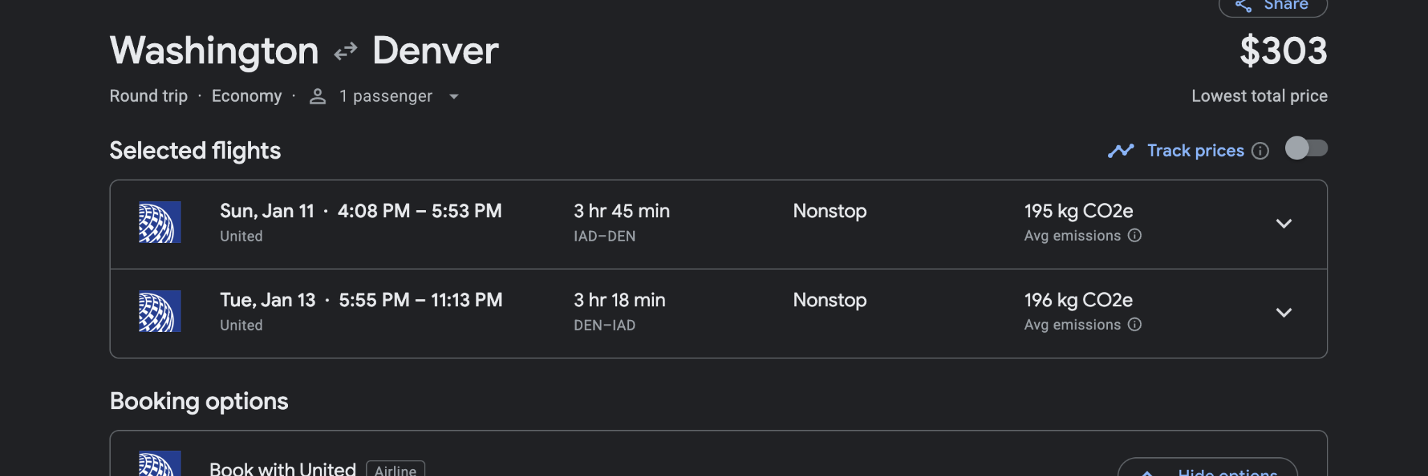

### Stakeholder Engagement Meeting - Los Angeles

In Los Angeles, where we currently partner with Imagine LA on their Benefit Navigator product, we will engage the California policy and benefit access communities.

<https://www.laparks.org/reservations/friendship-auditorium#:~:text=FRIENDSHIP%20AUDITORIUM%20%3B%201st%206>

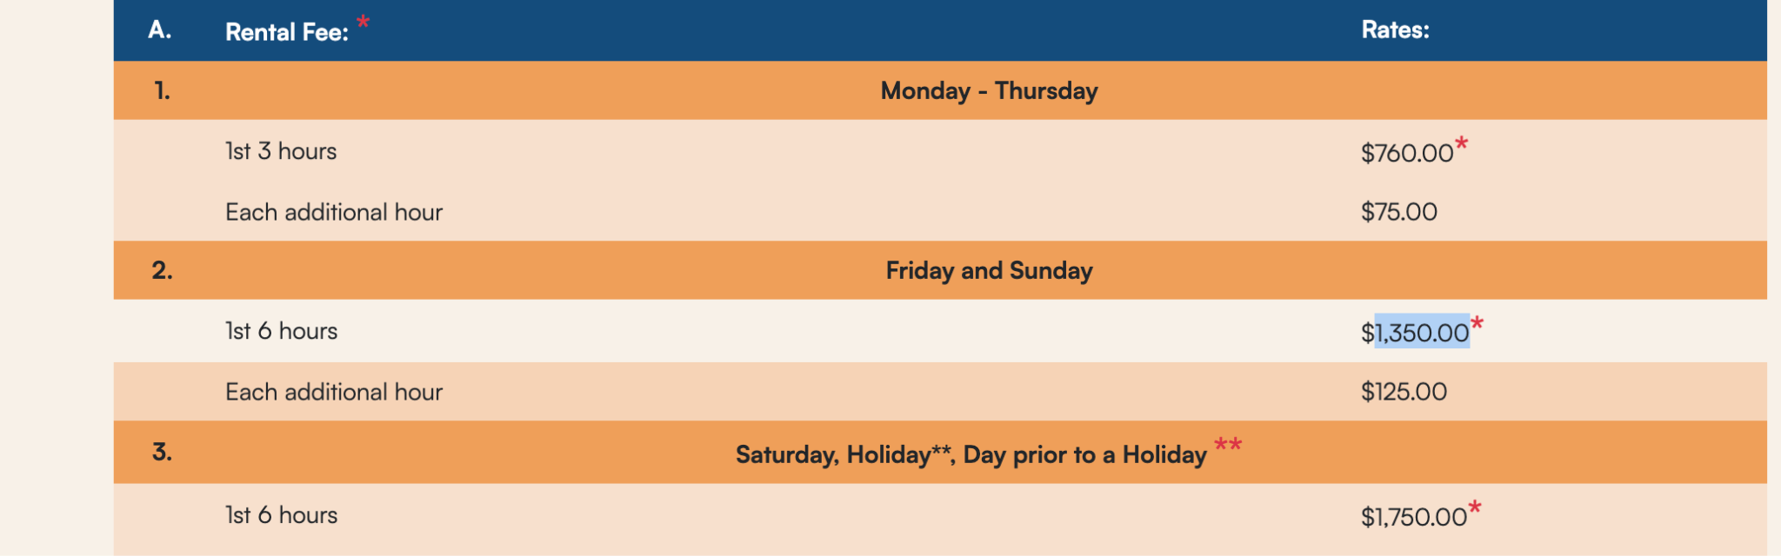

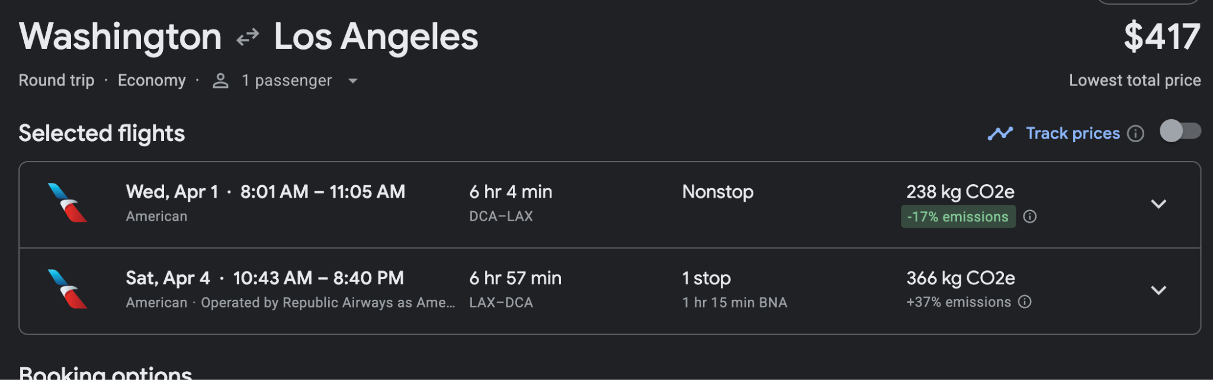

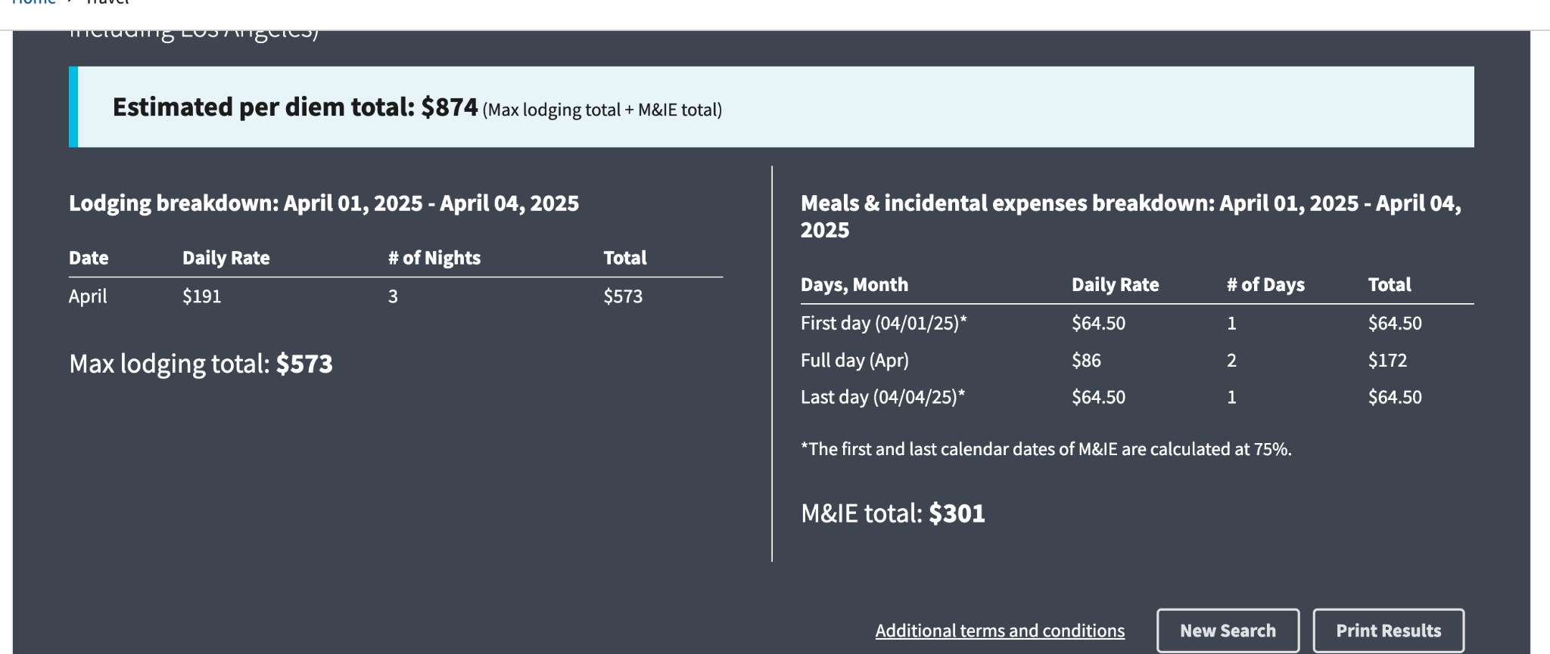

### Stakeholder Engagement Meeting - San Francisco

In San Francisco, we will engage the civic tech and broader technology communities.

Venue: $55/hr * 8 hours = $440

<https://womensbuilding.org/room-rentals/audre-lorde-room/#:~:text=Weekdays%20Before%205pm%20%2455%2Fhr%C2%A0,apply%2C%20depending%20on%20event%20details>

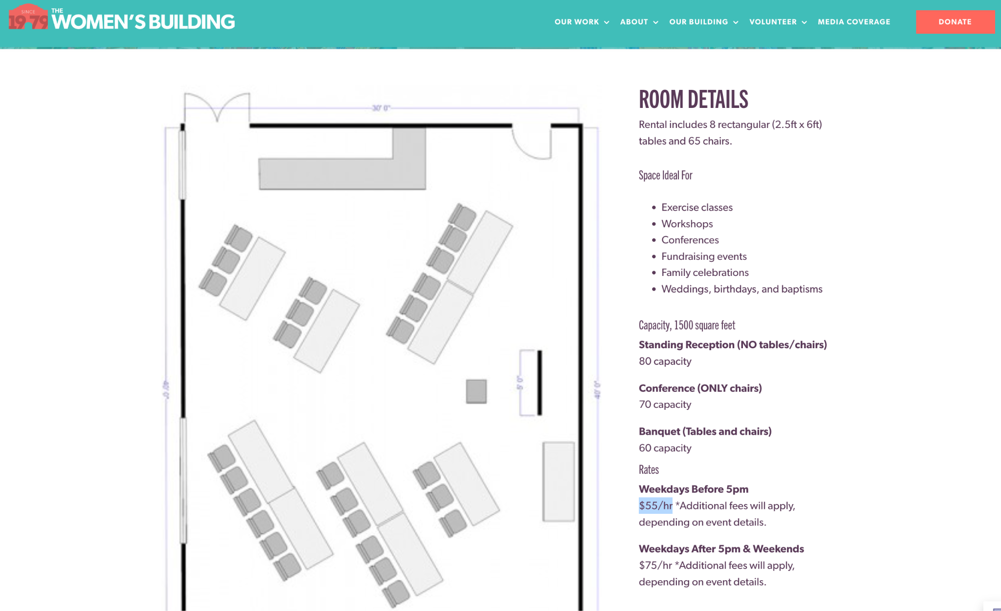 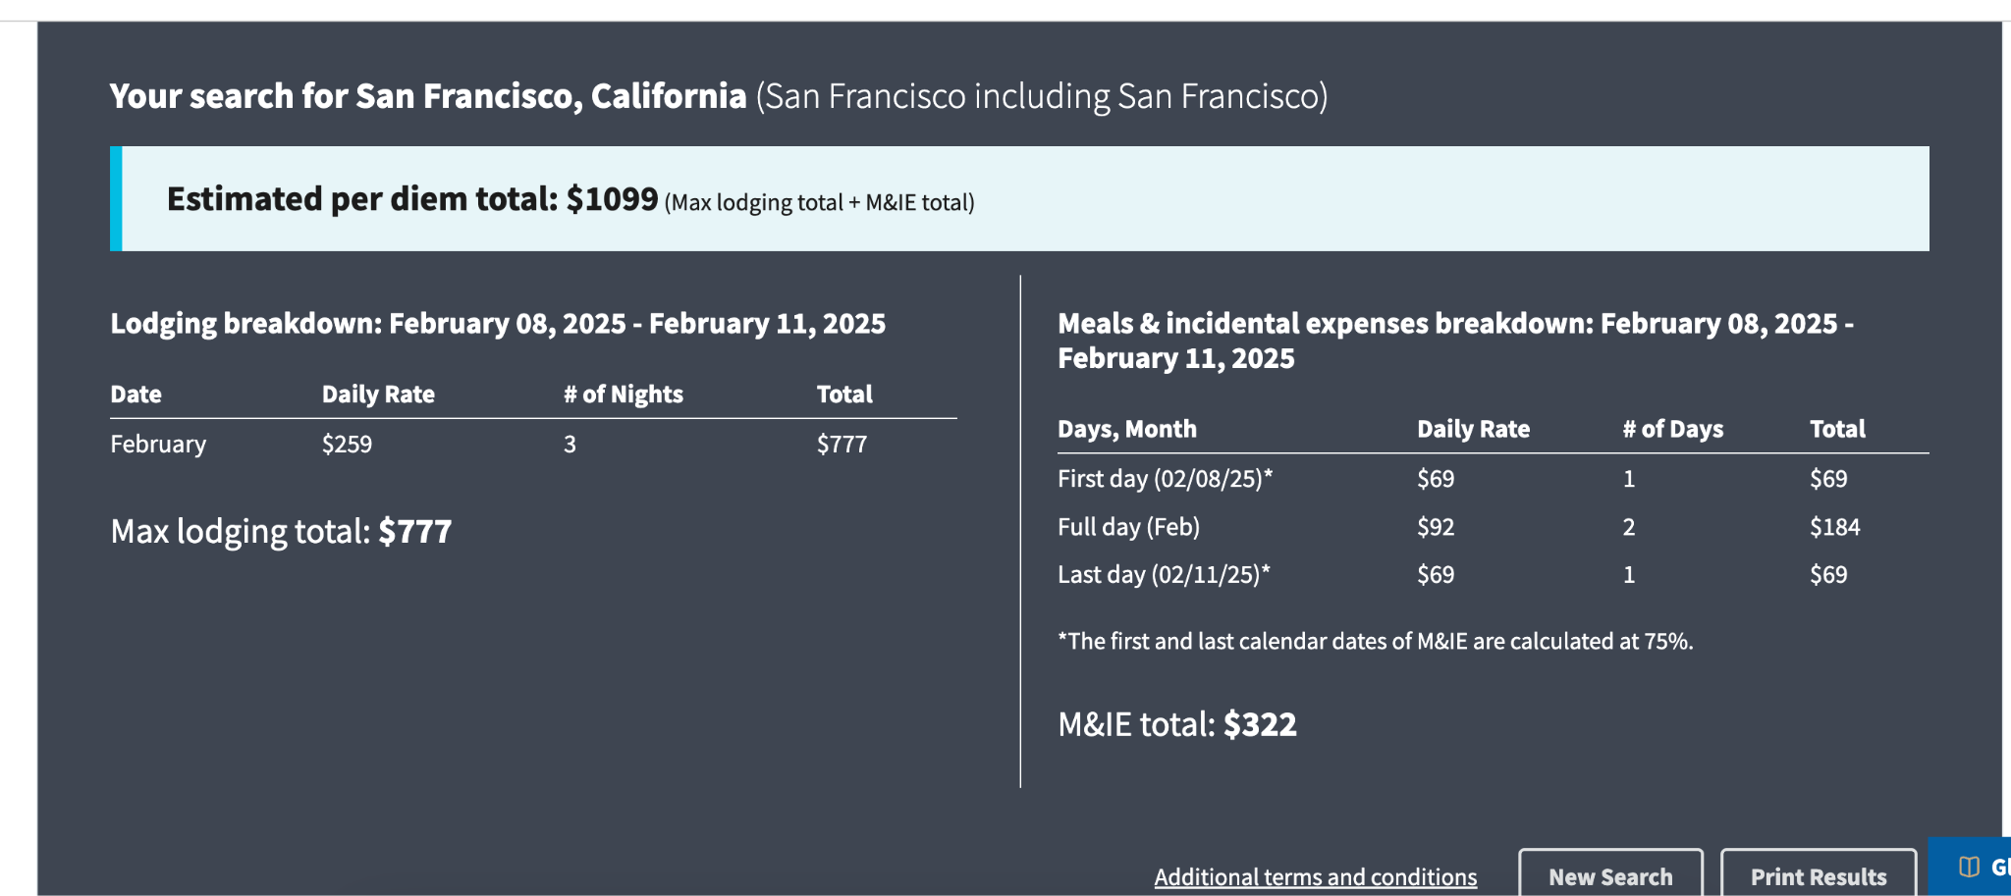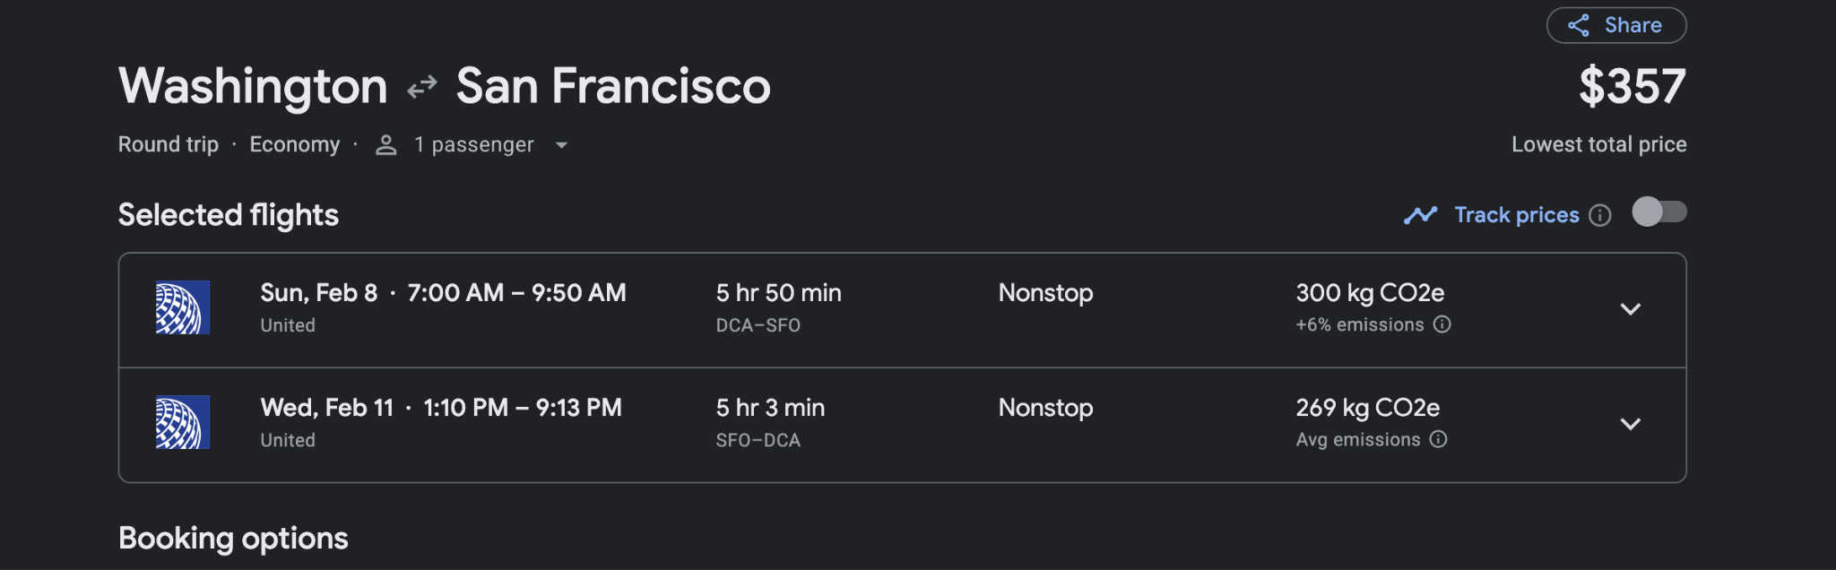

# Appendix 1: Dan Feenberg letter of collaboration

**DANIEL RICHARD FEENBERG, Ph.D.***Research Associate, National Bureau of Economic Research*

1050 Massachusetts Avenue  
Cambridge, Massachusetts 02138

Email: feenberg@gmail.com  
Phone: (617) 682-6204

June 10, 2025

National Science Foundation  
Pathways to Enable Open-Source Ecosystems (POSE) Program  
2415 Eisenhower Avenue  
Alexandria, VA 22314

**Re: Letter of Commitment for External Mentor Role - PSL Foundation POSE Phase I Proposal**

Dear NSF POSE Review Committee,

I am writing to confirm my commitment to serve as an external mentor for the PSL Foundation's NSF POSE Phase I proposal. I am enthusiastic about supporting the PSL Foundation's initiative to develop an open-source ecosystem for tax policy modeling through their PolicyEngine project.

**Qualifications and Relevant Experience**

I bring over 43 years of experience in tax policy modeling and economic research to this mentorship role. My qualifications include:

* **Research Associate, National Bureau of Economic Research (NBER)** (1980-present), where I have developed and maintained TAXSIM, the leading tax simulation model used by academic researchers worldwide
* **Ph.D. in Economics**, Princeton University (1980)
* **Economist**, U.S. Treasury Office of Tax Analysis (1976, 1989-1990)
* Author of numerous peer-reviewed publications on tax policy analysis, tax simulation methodology, and public finance
* Extensive experience in developing computational models for policy analysis and maintaining open-source research tools

My work on TAXSIM over the past four decades has given me deep expertise in the challenges and opportunities of building sustainable, accurate tax modeling infrastructure. I am particularly well-positioned to advise the PSL Foundation on validation strategies, model architecture, and building trust within the academic and policy research communities.

**Commitment and Availability**

I commit to providing approximately 41 hours of mentorship support for the PSL Foundation team during the POSE Phase I period. My specific commitments include:

1. **Full participation in the I-Corps-style training program** required by NSF, including all mentor sessions and activities
2. **Regular consultation** with the PSL Foundation team on technical aspects of tax modeling, validation methodologies, and open-source development practices
3. **Strategic guidance** on building partnerships with academic researchers and policy institutions
4. **Technical advisory support** on cross-validation strategies between the PSL Foundation's PolicyEngine open-source emulator and established models like TAXSIM

I understand that this role requires active engagement throughout the POSE Phase I period, and I have the flexibility in my schedule to fulfill these responsibilities. I will make myself available for scheduled training sessions, team meetings, and ad-hoc consultations as needed within the allocated hours.

**Support for the Project**

The PSL Foundation's mission to create an open-source, transparent tax policy modeling ecosystem through PolicyEngine aligns strongly with my own commitment to advancing rigorous, accessible tools for policy analysis. The development of open-source alternatives in this space will enhance reproducibility, enable broader participation in policy research, and ultimately lead to better-informed policy decisions.

I am particularly excited about the opportunity to help the PSL Foundation establish best practices for model validation and accuracy testing, drawing on my decades of experience maintaining TAXSIM. The cross-validation work between TAXSIM and the PolicyEngine models will be valuable for both projects and the broader research community.

**Terms of Engagement**

I understand that my participation is contingent upon the PSL Foundation receiving the NSF POSE Phase I award. Upon award notification, I will work with the PSL Foundation to formalize our arrangement as an independent contractor at a rate of $90 per hour for the committed 41 hours of mentorship.

I look forward to contributing to the success of this important initiative. Please do not hesitate to contact me if you require any additional information.

Sincerely,

Daniel Richard Feenberg  
Research Associate, NBER

